Assignment Module-24

- Different Types of Hacking Methods
Answer: Hacking methods usually refers to techniques attackers use to gain unauthorized access, steal information, disrupt systems, or manipulate users. In cybersecurity education, these are studied so organizations can defend against them.
A. Password Attacks:
Attempts to obtain or guess passwords.
Common methods:
- Brute Force Attack – tries every possible password combination.
- Dictionary Attack – uses a list of common passwords/words.
- Credential Stuffing – reuses leaked username/password combinations.
- Keylogging – records keyboard input.
- Phishing – tricks users into revealing passwords.
B. Malware Attacks:
Malicious software used to damage or control systems.
Types include:
- Virus – infects files/programs.
- Worm – spreads automatically across networks.
- Trojan Horse – appears legitimate but is malicious.
- Ransomware – encrypts data and demands payment.
- Spyware – secretly collects information.
C. Network Hacking:
Targets network communications and infrastructure.
Examples:
- Packet sniffing
- Session hijacking
- DNS spoofing
- Man-in-the-Middle (MITM) attacks
- ARP poisoning
D. Web Application Attacks:
Attacks against websites and web apps.
Examples:
SQL Injection
- Cross-Site Scripting (XSS)
- Cross-Site Request Forgery (CSRF)
- File Inclusion attacks
E. Social Engineering:
Manipulating people instead of systems.
Methods:
- Phishing emails
- Vishing (voice phishing)
- Smishing (SMS phishing)
- Impersonation
- Baiting
F. Wireless Attacks:
Targets Wi-Fi and wireless communications.
Examples:
- Rogue access points
- Evil twin attacks
- Wi-Fi password cracking
- Bluetooth attacks
G. Denial-of-Service (DoS/DDoS):
Overloads systems or servers so legitimate users cannot access them.
H. Insider Attacks:
Performed by employees or trusted individuals misusing access privileges.

- Types of Password Attacks
Answer: Password attacks are techniques used to obtain or bypass passwords.
1. Brute Force Attack: The attacker systematically tries all possible combinations.
Characteristics:
- Very slow on strong passwords
- Effective against weak passwords
- Can be detected by repeated login attempts
2. Dictionary Attack: Uses a predefined list of common passwords and words.
Examples:
- password123
- qwerty
- admin
Faster than brute force.
3. Hybrid Attack: Combines dictionary words with variations.
Example:
- admin@123
- welcome2025
4. Rainbow Table Attack: Uses precomputed hash tables to reverse password hashes.
Defense:
- Salting passwords
- Strong hashing algorithms
5. Credential Stuffing:
- Uses leaked credentials from previous data breaches.
- Works because many users reuse passwords.
6. Phishing Attack: Fake websites or emails trick users into revealing passwords.
7. Keylogger Attack: Malware records keystrokes typed by users.
8. Shoulder Surfing: Watching someone type their password.
9. Password Spraying: Trying a few common passwords across many accounts.
Example:
- Password@123
- Welcome1
- Explain Password Cracking Tools: pwdump7, Medusa and Hydra
Answer: These tools are commonly discussed in ethical hacking and penetration testing courses. They should only be used in authorized lab or security-testing environments.

A. pwdump7
Purpose: Extracts password hashes from Windows systems.
Main Features:
- Dumps LM and NTLM password hashes
- Works on Windows systems
- Used for forensic/security auditing purposes
How It Works:
- Accesses Windows Security Account Manager (SAM)
- Extracts stored password hashes
- Hashes can then be tested offline
Security Risk: If attackers obtain hashes, they may attempt offline password cracking.
Defensive Measures:
- Disable LM hashes
- Use strong passwords
- Enable multi-factor authentication
- Restrict administrator access
B. Medusa
Purpose: A fast network login brute-force tool.
Supported Protocols:
- SSH
- FTP
- HTTP
- SMB
- Telnet
- RDP (through modules)
Features:
- Parallelized login testing
- Modular architecture
- High-speed authentication testing
Typical Security Use: Used by penetration testers to identify weak credentials on authorized systems.
Risks: Can lock accounts or trigger security alerts if misused.

C. Hydra
Purpose: A popular password auditing and network login testing tool.
Supported Services:
- SSH
- FTP
- SMTP
- HTTP forms
- MySQL
- PostgreSQL
- SMB
- Telnet
Features:
- Multi-threaded operation
- Supports many protocols
- Fast credential testing
Typical Ethical Use: Security professionals use it to test password policies and identify weak credentials in controlled environments.
Protection Against Such Tools:
- Account lockout policies
- Multi-factor authentication
- Strong passwords
- Rate limiting
- Intrusion detection systems
- Explain Types of Steganography with QuickStego and Echo
Answer: What is Steganography?
Steganography is the practice of hiding information inside another file or medium, so the existence of the hidden data is concealed. Unlike encryption, steganography hides the presence of communication itself.
Types of Steganography
A. Text Steganography: Hides information inside text.
Methods:
- Extra spaces
- Hidden characters
- Character patterns
B. Image Steganography: Hides data inside image files.
Commonly uses:
- Least Significant Bit (LSB) modification
Most common form of steganography.
C. Audio Steganography: Hides data inside audio files.
Methods:
- Echo hiding
- Phase coding
- LSB audio encoding
D. Video Steganography: Hides information inside video frames and audio streams.
E. Network Steganography: Hides data inside network protocols or packet headers.

QuickStego
Purpose: A Windows-based image steganography tool.
Features:
- Hides text messages inside images
- Simple graphical interface
- Supports BMP/JPEG images
Basic Working:
- Select an image
- Enter hidden text
- Save stego-image
- Receiver extracts hidden message
Educational Use: Useful for demonstrating image steganography concepts in cybersecurity labs.

Echo Hiding (Audio Steganography)
Concept: A secret message is hidden inside an audio signal by introducing small echoes.

How It Works:
The hidden data is represented through:
- Echo delay
- Echo amplitude
- Decay rate
These changes are subtle and difficult for humans to detect.
Advantages of Steganography:
- Conceals communication
- Adds secrecy
- Can be combined with encryption
Limitations:
- Hidden data may be destroyed by compression
- Large hidden payloads may reduce quality
- Detection tools can identify anomalies

- Perform Practical on key logger tool.
Answer:

Malware:

- Define Types of Viruses.

Answer: Types of Viruses

- Boot Sector Virus: Infects the boot sector of a hard drive or USB device. It activates when the computer starts.

- File Infector Virus: Attaches itself to executable files (such as .exe files). It spreads when the infected program runs.

- Macro Virus: Written using macro languages and commonly infects documents like Microsoft Word or Microsoft Excel files.

- Multipartite Virus: Infects both boot sectors and files, making it difficult to remove.

- Resident Virus: Installs itself in the computer’s memory and infects files while the system operates.

- Direct Action Virus: Activates only when the infected file is executed and usually targets specific files.

- Polymorphic Virus: Changes its code or signature repeatedly to avoid detection by antivirus software.

- Metamorphic Virus: Rewrites its own code completely each time it spreads, making detection even harder.

- Overwrite Virus: Overwrites the content of infected files, destroying the original data.

- Stealth Virus: Hides its presence by tricking the operating system or antivirus software.

- Web Scripting Virus: Uses malicious scripts in web pages or browser-based applications to spread.

- Network Virus: Spreads through computer networks and can quickly infect multiple systems.

- Create virus using Http Rat Trojan tool.

Answer:
- Open a notepad and write notepad
- Save this file has .txt

- Change file name from .txt to .bat file and save


.txt to .bat file

- When we double click on .bat file, the bat file directly open in cmd
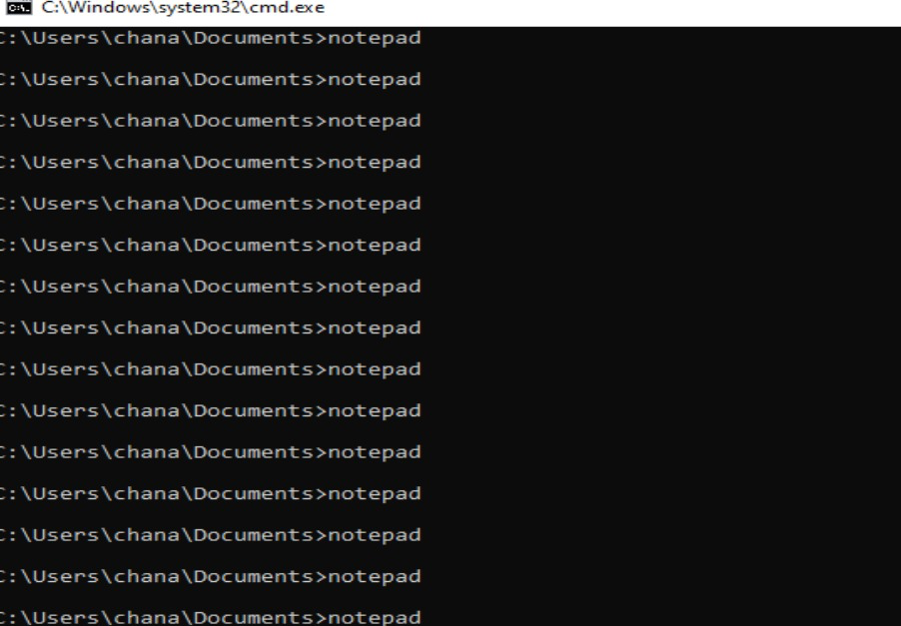

If we don’t click inside the cmd it continuously showing above mention image and it looks like DDOS attack.
- Explain any one Antivirus with example.

Answer: Norton Antivirus is a cybersecurity software developed by NortonLifeLock. It is designed to protect computers, smartphones, and other devices from viruses, malware, ransomware, spyware, and phishing attacks.

How Norton Antivirus Works:
- Real-time protection: Continuously scans files, downloads, and applications.
- Virus detection: Uses a large database of known threats plus AI-based behavior analysis.
- Automatic removal: Detects and removes or quarantines harmful files.
- Web protection: Blocks unsafe websites and phishing links.
- Regular updates: Keeps virus definitions updated to detect new threats.
Example:
- Suppose you download a cracked software file from an unknown website.
- When you try to open it, Norton Antivirus scans the file instantly.
- It detects that the file contains a Trojan virus hidden inside.
- Norton blocks the file from running and shows a warning like:
“Threat detected and removed.”
- The infected file is moved to quarantine, so it cannot harm your system.
Conclusion: Norton Antivirus helps protect users by detecting threats early, blocking malicious activities, and ensuring safe browsing and file usage.

